|  |  |
| --- | --- |
| A picture of a winding road and trees  Magic Square  KIST College | Hawana Tamang  BIT 6th Semester |

# Magic Squares

1. **3 x 3**

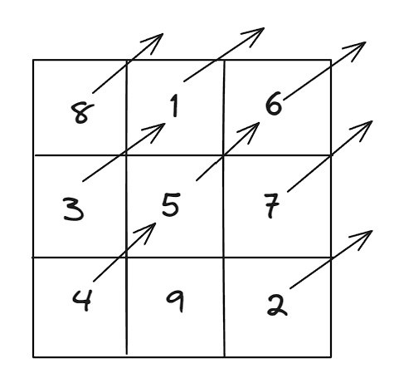

**Step 1**: Place the first number i.e., 1 in the middle of the box (if the box is made up of odd number).

**Step2:** Then point the arrow of the number (i.e., 1) to the right side.

**Step3:** Place the second number at the bottom of the column where the arrow is pointed.

**Step4:** Place all the numbers till all the boxes are filled.

**Step5:** Stop

1. **4 x 4**

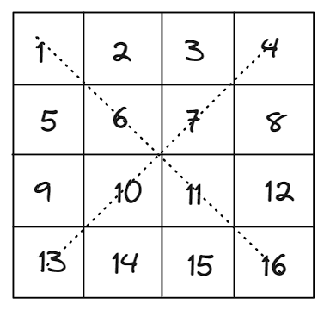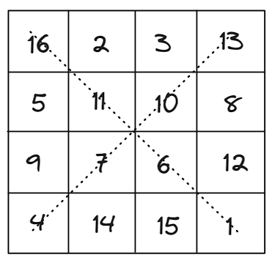

**Step1:** Place all the values from number 1 to 16 serially from the top left corner of the box.

**Step2:** Now make an imaginary or dotted line in the diagonal section from top left to bottom right and top right to bottom left.

**Step3:** Now flip the numbers placed in within the diagonal line in opposite direction as shown in figure.

PS: if number 1 was in top left then it goes to bottom right and vice versa.

**Step4:** After the new numbers in diagonal section is placed then place the other numbers serially.

**Step5:** Stop

1. **5 x 5**

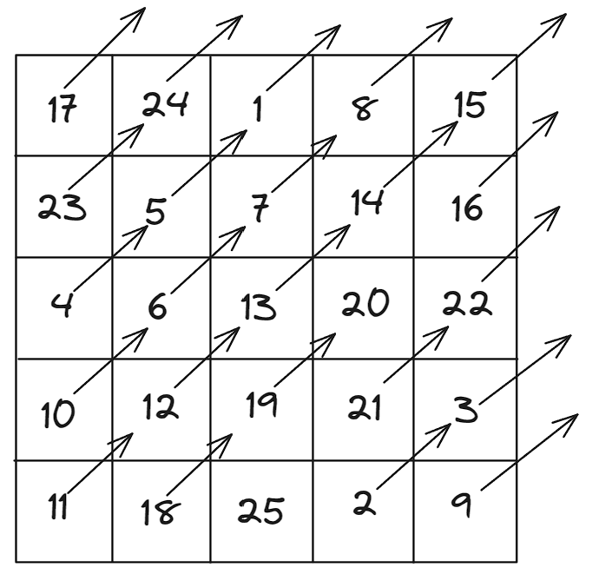

**Step 1**: Place the first number i.e., 1 in the middle of the box (if the box is made up of odd number).

**Step2:** Then point the arrow of the number (i.e., 1) to the right side.

**Step3:** Place the second number at the bottom of the column where the arrow is pointed.

**Step4:** Place all the numbers till all the boxes are filled.

**Step5:** Stop

1. **6 x 6**

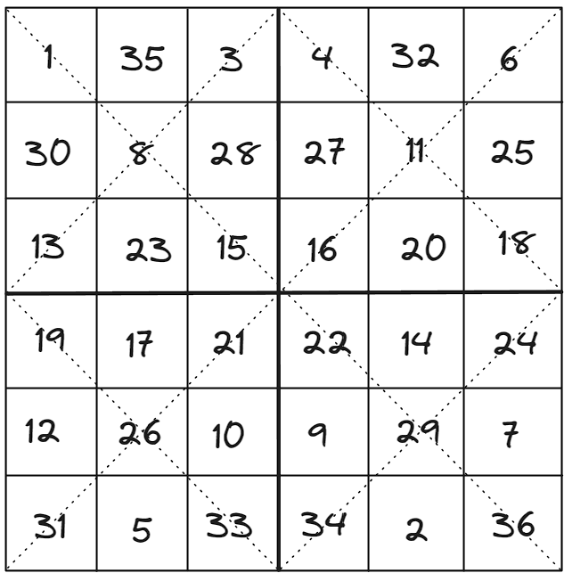

**Step1:** Make the box according to the given criteria.

**Step2:** Divide the box from the middle with having 3x3 boxes inside the 6x6 box.

**Step3:** Then create the imaginary or dotted line for the whole box in diagonal section.

**Step4:** Place the numbers serially from top left corner to the bottom right corner, but the number should be placed on those blocks where dotted lines are diagonally placed. (Eg: 1 and 3 are placed on those blocks where the diagonal dotted line passes)

**Step5:** Assume that the bottom right corner (where number 36 is placed) is 1 (imagine it), then serially fill the other numbers which are left to be filled out, from left to right side.

PS: The numbers already present in the diagonal section should not be repeated.

**Step6:** Stop

1. **7 x 7**

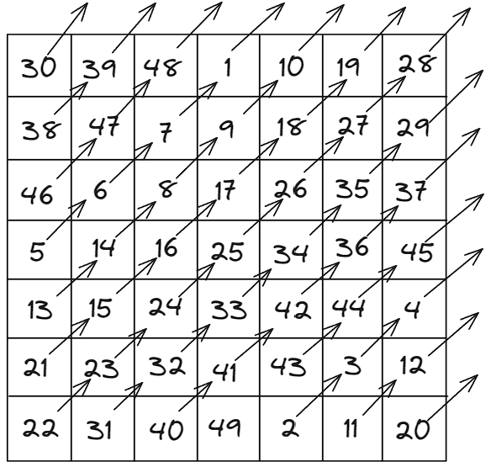

**Step 1**: Place the first number i.e., 1 in the middle of the box (if the box is made up of odd number).

**Step2:** Then point the arrow of the number (i.e., 1) to the right side.

**Step3:** Place the second number at the bottom of the column where the arrow is pointed.

**Step4:** Place all the numbers till all the boxes are filled.

**Step5:** Stop

1. **8 x 8**

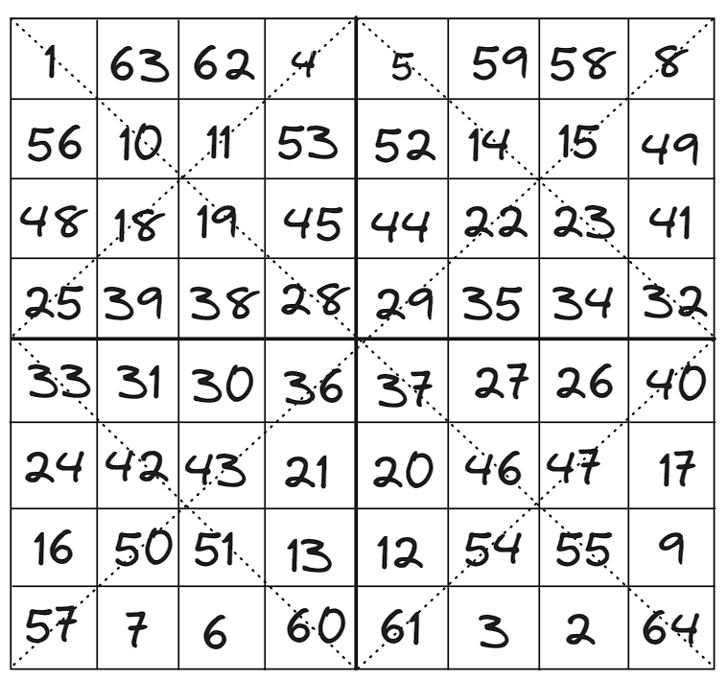

**Step1:** Make the box according to the given criteria.

**Step2:** Divide the box from the middle with having 4x4 boxes inside the 8x8 box.

**Step3:** Then create the imaginary or dotted line for the whole box in diagonal section.

**Step4:** Place the numbers serially from top left corner to the bottom right corner, but the number should be placed on those blocks where dotted lines are diagonally placed. (Eg: 1 and 3 are placed on those blocks where the diagonal dotted line passes)

**Step5:** Assume that the bottom right corner (where number 36 is placed) is 1 (imagine it), then serially fill the other numbers which are left to be filled out , from left to right side.

PS: The numbers already present in the diagonal section should not be repeated.

**Step6:** Stop